

Practical No. : 4
Aim - Use Function Types, Scope and Closures; Apply Try-Catch; Build a Palindrome Checker
Software/Tools Required –
VSCode, Chrome, HTML, CSS3, Javascript (ES6)
Experiment Program Code –
index.html
<!DOCTYPE html>
<html>
<head>
<title>Palindrome Checker</title>
<script src ="script.js"></script>
<link rel="stylesheet" href="style.css">
</head>
<body>
<h2>PALINDROME CHECKER</h2>
<label> Enter a word: </label>
<input type="text" id="word"><br><br>
<input type="button" value="Check Palindrome" onclick="checkPalindrome()">
</body>
</html>
script.js
function reverseString(str) {
return str.split("").reverse().join("");
}

function message(){
var msg =" Palindrome Checker";
function display(){
return msg;
}
return display;
}
function checkPalindrome(){
try {
var word = document.getElementById("word").value;

if(word ==""){
throw "Please enter a word";
}
if(!/^[a-zA-Z]+$/.test(word)){
throw "Only alphabets are allowed";
}
if(word.length < 3){
throw "Please enter at least 3 characters";
}
if(word.length > 20){
throw " Maximum 20 characters are allowed";
}
let input = word.toLowerCase();
var reversed = reverseString(input);
if(input==reversed){
document.write("<h2>"+message()()+"</h2>");
document.write("<hr>");
document.write("<b> Word : </b>"+word+"<br><br>");
document.write("<b> Result : </b>"+word+" is a palindrome");
}
else{
document.write("<h2>"+message()()+"</h2>");
document.write("<hr>");
document.write("<b> Word : </b>"+word+"<br><br>");
document.write("<b> Result : </b>"+word+" is not a palindrome");
}
}
catch(error){
alert(error);
}
}
Style.css
@import url('https://fonts.googleapis.com/css2?family=Poppins:wght@300;400;500;600;700&display=swap');

*{
margin:0;
padding:0;
box-sizing:border-box;
font-family:'Poppins',sans-serif;
}

body{
min-height:100vh;
display:flex;
justify-content:center;
align-items:center;
background:
radial-gradient(circle at top left,#dbeafe 0%,transparent 40%),
radial-gradient(circle at bottom right,#fde2ff 0%,transparent 40%),
linear-gradient(135deg,#f8fbff,#eef5ff);
}

.container{
width:470px;
background:#fff;
border-radius:28px;
padding:40px;
box-shadow:
0 20px 60px rgba(0,0,0,.10),
0 8px 25px rgba(79,140,255,.10);
transition:.35s;
}

.container:hover{
transform:translateY(-8px);
box-shadow:
0 30px 70px rgba(0,0,0,.12),
0 10px 35px rgba(79,140,255,.18);
}

h2{
text-align:center;
font-size:34px;
color:#243b53;
margin-bottom:35px;
font-weight:700;
}

h2::after{
content:"";
display:block;
width:80px;
height:5px;
margin:12px auto 0;
border-radius:20px;
background:linear-gradient(to right,#6c63ff,#5ac8fa);
}

label{
display:block;
margin-bottom:10px;
font-size:16px;
font-weight:600;
color:#4b5563;
}

input[type=text]{
width:100%;
padding:16px;
border:none;
border-radius:16px;
background:#f4f7fc;
font-size:16px;
transition:.3s;
box-shadow:inset 0 0 0 2px transparent;
}

input[type=text]:focus{
outline:none;
background:#fff;
box-shadow:
inset 0 0 0 2px #6c63ff,
0 8px 20px rgba(108,99,255,.15);
}

input[type=button]{
width:100%;
margin-top:25px;
padding:16px;
border:none;
border-radius:16px;
background:linear-gradient(135deg,#6c63ff,#5ac8fa);
color:#fff;
font-size:17px;
font-weight:600;
cursor:pointer;
transition:.3s;
}

input[type=button]:hover{
transform:translateY(-3px);
box-shadow:0 12px 25px rgba(90,200,250,.35);
}

#result{
margin-top:30px;
padding:20px;
border-radius:18px;
background:#f8fbff;
border:2px solid #e2ebff;
color:#374151;
line-height:1.8;
animation:fade .4s ease;
}

#result b{
color:#5b5ce2;
}

hr{
border:none;
border-top:1px solid #d9e4f5;
margin:12px 0;
}

@keyframes fade{
from{
opacity:0;
transform:translateY(15px);
}
to{
opacity:1;
transform:translateY(0);
}
}

Output –
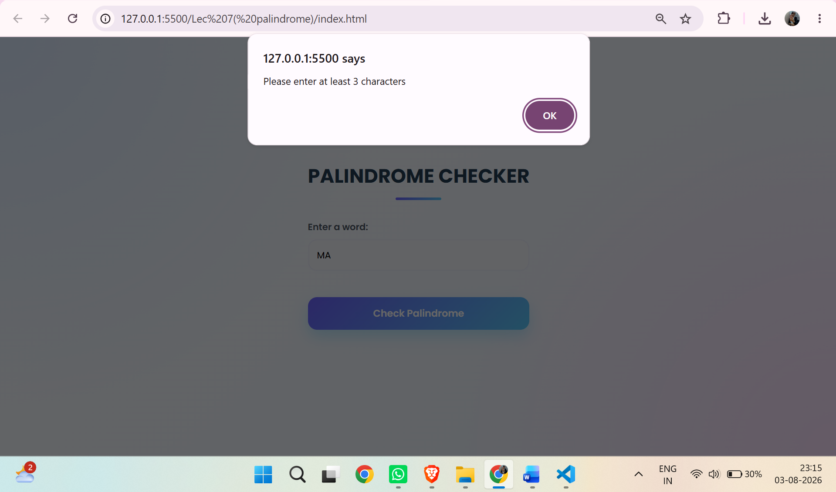
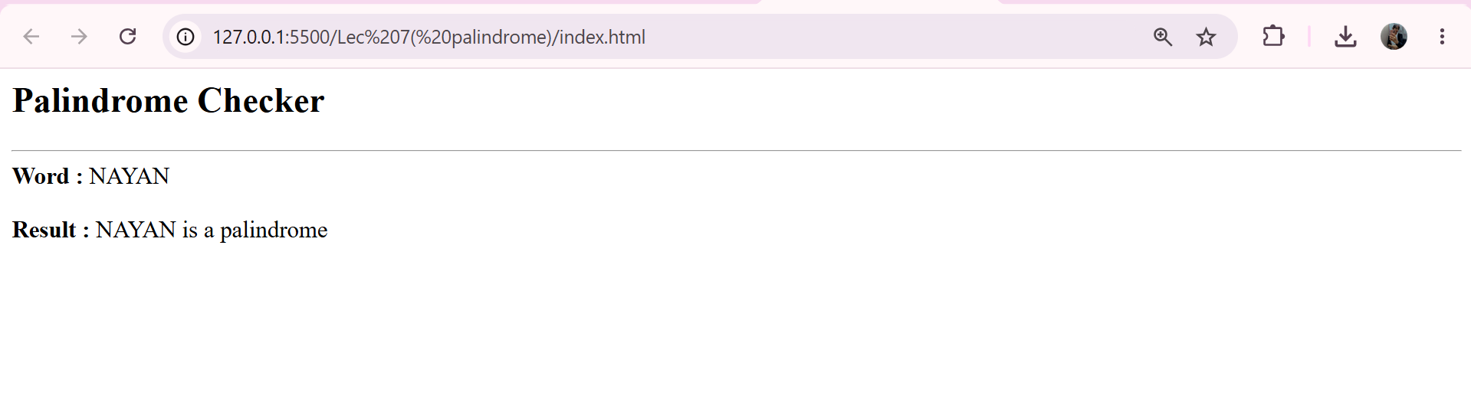
Case Study Title –
Vehicle Registration Number Validation Webpage using Functions, Scope, and Try-Catch

Case Study Program Code –

index.html
<!DOCTYPE html>
<html lang="en">
<head>
<meta charset="UTF-8">
<meta name="viewport" content="width=device-width, initial-scale=1.0">
<title>RTO Vehicle Registration Portal</title>

<link rel="stylesheet" href="style.css">

<link href="https://fonts.googleapis.com/css2?family=Poppins:wght@300;400;500;600;700&display=swap" rel="stylesheet">

<link rel="stylesheet" href="https://cdnjs.cloudflare.com/ajax/libs/font-awesome/6.6.0/css/all.min.css">

</head>

<body onload="displayDateTime();setInterval(displayDateTime,1000)">

<div class="overlay">

<div class="top">

<div class="car">
<i class="fa-solid fa-car-side"></i>
</div>

<h1>RTO Vehicle Number Validator Portal</h1>

<p>Validate Indian Vehicle Registration Number</p>

<div id="datetime"></div>

</div>

<div class="container">

<input
type="text"
id="vehicleNo"
placeholder="Enter Vehicle No. (MH12AB1234)"
maxlength="10"
autocomplete="off">

<button onclick="validateVehicle()">
<i class="fa-solid fa-circle-check"></i>
Validate
</button>

<div id="result"></div>

</div>

<footer>

Designed by <strong>Rudrakshi Bhandekar</strong> | PRN: 24070521012<br>
</footer>

</div>

<script src="script.js"></script>

</body>
</html>

Style.css

*{
margin:0;
padding:0;
box-sizing:border-box;
font-family:'Poppins',sans-serif;
}

body{
height:100vh;
background:url("https://t4.ftcdn.net/jpg/07/11/03/63/360_F_711036356_0RgP9ky74c46q9X6EOT5GydYSFq3grEw.jpg") center center/cover no-repeat fixed;
overflow:hidden;
}

.overlay{
width:100%;
height:100vh;
background:rgba(0,0,0,.45);
display:flex;
flex-direction:column;
justify-content:space-between;
align-items:center;
padding:30px 20px;
}

.top{
text-align:center;
color:#fff;
animation:fadeDown 1s ease;
}

.car{
font-size:65px;
color:#00d4ff;
margin-bottom:12px;
animation:float 2s ease-in-out infinite;
}

.top h1{
font-size:42px;
font-weight:700;
letter-spacing:1px;
text-shadow:0 4px 10px rgba(0,0,0,.5);
margin-bottom:8px;
}

.top p{
font-size:18px;
font-weight:300;
margin-bottom:15px;
}

#datetime{
display:inline-block;
padding:10px 22px;
background:rgba(255,255,255,.15);
border:1px solid rgba(255,255,255,.3);
backdrop-filter:blur(8px);
border-radius:30px;
font-size:15px;
}

.container{
width:470px;
background:rgba(255,255,255,.16);
backdrop-filter:blur(18px);
border:1px solid rgba(255,255,255,.25);
padding:40px;
border-radius:20px;
box-shadow:0 20px 45px rgba(0,0,0,.35);
animation:fadeUp 1s ease;
}

input{
width:100%;
padding:16px;
font-size:18px;
border:none;
border-radius:12px;
outline:none;
text-transform:uppercase;
letter-spacing:2px;
transition:.3s;
}

input:focus{
transform:scale(1.02);
box-shadow:0 0 18px #00d4ff;
}

button{
width:40%;
margin-top:20px;
padding:8px;
font-size:18px;
font-weight:600;
border:none;
border-radius:12px;
cursor:pointer;
background:linear-gradient(90deg,#0072ff,#00c6ff);
color:white;
transition:.3s;
}

button:hover{
transform:translateY(-3px);
box-shadow:0 10px 25px rgba(0,123,255,.5);
}

#result{
margin-top:20px;
}

.success{
padding:15px;
border-radius:10px;
background:#d4edda;
color:#155724;
font-weight:600;
animation:slide .4s ease;
}

.error{
padding:15px;
border-radius:10px;
background:#f8d7da;
color:#721c24;
font-weight:600;
animation:slide .4s ease;
}

footer{
width:100%;
text-align:center;
color:white;
font-size:15px;
padding:15px 0;
background:rgba(0,0,0,.35);
backdrop-filter:blur(6px);
}

footer strong{
color:#00d4ff;
}

@keyframes float{
0%{transform:translateY(0);}
50%{transform:translateY(-10px);}
100%{transform:translateY(0);}
}

@keyframes fadeDown{
from{
opacity:0;
transform:translateY(-40px);
}
to{
opacity:1;
transform:translateY(0);
}
}

@keyframes fadeUp{
from{
opacity:0;
transform:translateY(40px);
}
to{
opacity:1;
transform:translateY(0);
}
}

@keyframes slide{
from{
opacity:0;
transform:translateY(20px);
}
to{
opacity:1;
transform:translateY(0);
}
}

@media(max-width:600px){

.top h1{
font-size:30px;
}

.container{
width:92%;
padding:30px;
}

.car{
font-size:50px;
}

}

script.js

function validateVehicle(){

const vehicle=document.getElementById("vehicleNo").value.trim();
const result=document.getElementById("result");

try{

if(vehicle==="")
throw"Vehicle Registration Number cannot be empty.";

if(vehicle.length!==10)
throw"Vehicle Registration Number must contain exactly 10 characters.";

if(!/^[A-Z]{2}/.test(vehicle))
throw"First two characters must be uppercase letters.";

if(!/^[A-Z]{2}[0-9]{2}/.test(vehicle))
throw"Third and fourth characters must be digits.";

if(!/^[A-Z]{2}[0-9]{2}[A-Z]{2}/.test(vehicle))
throw"Fifth and sixth characters must be uppercase letters.";

if(!/^[A-Z]{2}[0-9]{2}[A-Z]{2}[0-9]{4}$/.test(vehicle))
throw"Last four characters must be digits.";

result.className="success";
result.innerHTML="✅ Vehicle Registration Number is Valid.";

}
catch(error){

result.className="error";
result.innerHTML="❌ "+error;
}
}

function displayDateTime(){

const now=new Date();

const options={
weekday:"long",
year:"numeric",
month:"long",
day:"numeric"
};
document.getElementById("datetime").innerHTML=
now.toLocaleDateString("en-IN",options)+"<br>"+now.toLocaleTimeString("en-IN");

}

Output –

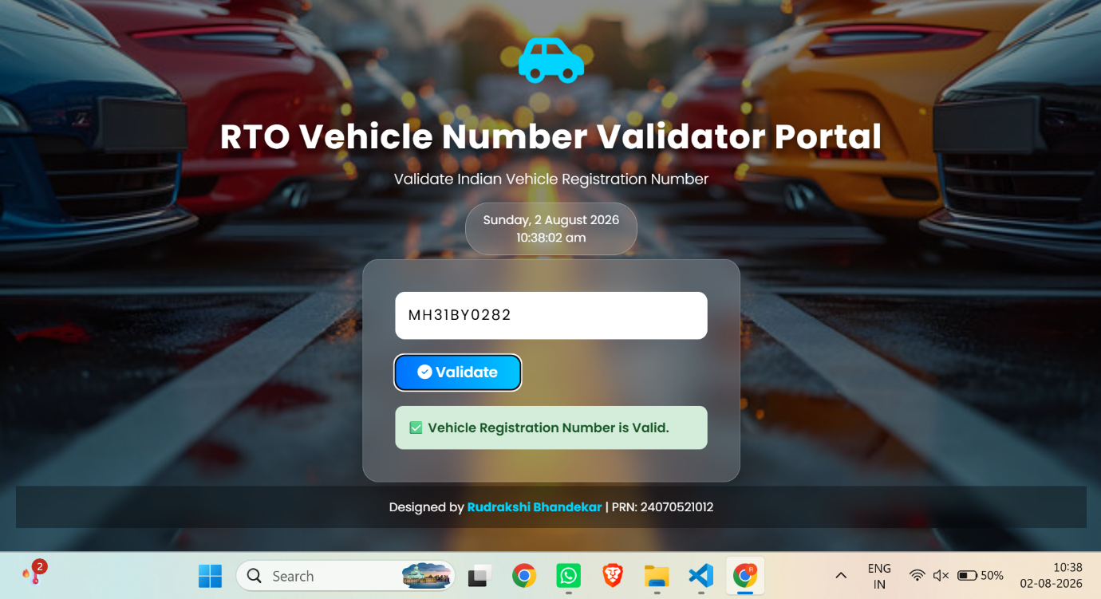
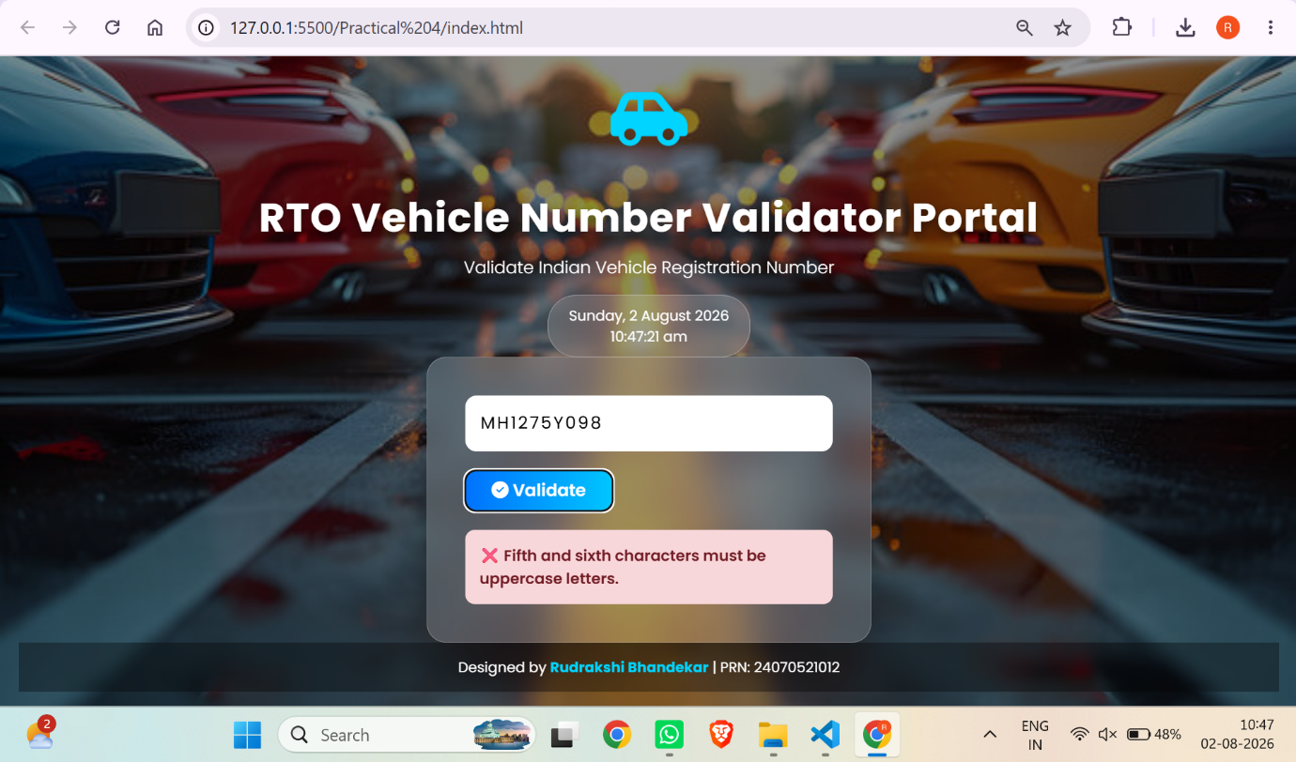

Conclusion –
The practical was completed successfully. Function types (Function Declaration, Function Expression, Arrow Function), scope (global, function, block), closures, and try-catch exception handling were implemented. A palindrome checker and a vehicle registration number validator were developed using JavaScript to validate user input and demonstrate string manipulation and error-handling concepts.

